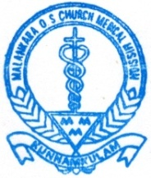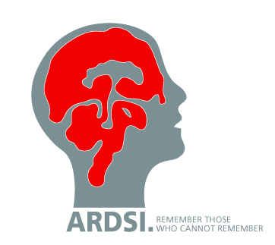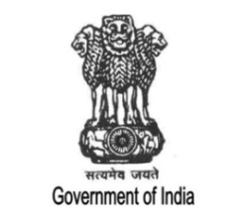

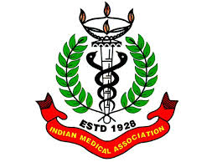 **INAUGURATION OF TWO MONTHS CERTIFICATE COURSE IN GERIATRIC CARE FOR BEDSIDE ASSISTANCE/ CARE TAKER**

**ORGANIZED BY**

**NATIONAL INSTITUTE OF SOCIAL DEFENCE (NISD) (OLDAGE DIVISION), AN AUTONOMOUS BODY UNDER MINISTRY OF SOCIAL JUSTICE AND EMPOWERMENT,**

**GOVT. OF INDIA**

**IN ASSSOCIATION WITH**

**ALZHEIMER’S AND RELATED DISORDERS SOCIETY OF INDIA, (ARDSI) AND INDIAN MEDICAL ASSOCIATION (IMA) KUNNAMKULAM**

**AT MALANKARA MEDICAL MISSION HOSPITAL, ADUPUTTY, KUNNAMKULAM.**

**Programme**

9.30 am Prayer :  **Nursing students**

Malankara Medical Mission Hospital, Kunnamkulam

9.35 am Welcome : **Dr. Jacob Roy K**,

Chairman, ADI

9.45 am Presidential address : **Shri. Mathew I Chemmannur**,

Secretary, MMM Hospital, Kunnamkulam

9.55 am Inauguration : **Shri. P.K. Biju**,

Hon’ble Member of Parliament

10.25 am Keynote Address : **Dr. Koshy George T**, President, IMA Kunnamkulam

10.40 am Felicitation : **Mrs. Chithralekha K.K**,

Child Development Officer, ICDS, Chowannoor.

10. 50 am Vote of Thanks : **Major Gopalakrishnan KP**,

National Coordinator, ARDSI.

11.00 am National Anthem